S T A T I O N 1 • T E M P E R A T U R E
- Standard Temperature is: _______°C or _______K
- Convert:
- 26.0 °C = _______ K b. 400 K = ________ °C
c. 100 K = ________ °C d. 135 °C = ________ K
e. ‒127 °C = ________ K f. 4 K = ________°C

3. What is the temperature of a sample of gas that has double the kinetic energy (motion energy) of a sample of gas at 80°C?

4. In Kinetic Molecular Theory, the temperature
- is the average kinetic energy of a sample
- depends on the collisions of gases against the walls of the container

S T A T I O N 2 • P R E S S U R E U N I T S

Standard Pressure is: 1 atm = 760 mmHg = 760 torr = 14.7 psi = 101.3 kPa
- Make the following conversions: (Show your work)
  - 325 kPa = ? atm b. 2284 torr = ? kPa

c. 48.0 mmHg = ? torr d. 1.85 atm = ? mmHg

2. In Kinetic Molecular Theory, the pressure
- is the average kinetic energy of a sample
- depends on the collisions of gases against the walls of the container

S T A T I O N 3 • G A S L A W P R O B L E M S

- A balloon has a volume of 5.00 L at 2.50 atm. What is the balloon’s volume at 1.50 atm?

- A balloon has a volume of 3.50 L at 21.0C when the air pressure is 1.05 atm. How many moles of gas are contained in the balloon?

S T A T I O N 4 • M O R E G A S L A W P R O B L E M S
- A balloon at 35ºC has a volume of 2.5 L. What is its volume at 45ºC?

- A balloon has a volume of 1.0 L at 21.0ºC and 750 mmHg. What is the balloon’s volume at STP?

S T A T I O N 5 • K I N E T I C M O L E C U L A R T H E O R Y

Explain the following observations in terms of the “kinetic molecular theory” (that is, what do the gas particles look like?)
- A balloon of gas is placed in a car on a hot day. The balloon gets larger. Explain.
The particles are moving (faster or slower) and collide with the walls of the balloon (more or less) often and with (more or less) force. The gas particles inside the balloon push (harder or softer) than the air particles outside of the balloon.

- A syringe is squeezed so the gas sample changes from 10 cc to 5 cc. The pressure doubles. Explain.
When the gas is squeezed, the distance particles must travel between collisions with the container wall is (longer or shorter) so the number of collisions (increase or decrease).

S T A T I O N 6 • I D E A L G A S L A W

- A 0.227 mol chunk of dry ice (solid CO₂) changes to gas. What is the volume of that gas measured at 27ºC and 740 mmHg?

- Calculate the moles of a gas sample if 3.0 grams of the gas in a 2.0 L container at 25ºC has a pressure of 2.294 atm.

S T A T I O N 7 • S T A T E S O F M A T T E R

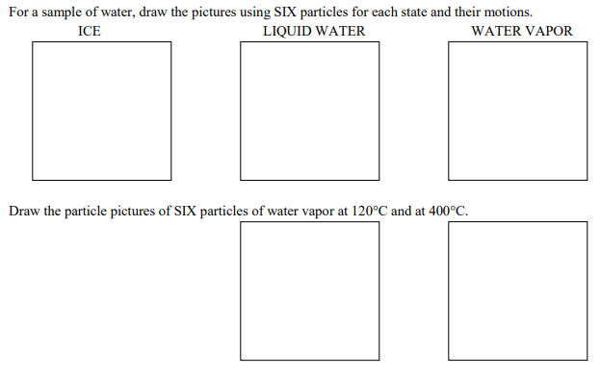

S T A T I O N 8 • G R A P H S O F V A R I A B L E S

